TITLE

# MEMORY PAGING VISUALIZATION TOOL

## A CAPSSTONE PROJECT REPORT

Submitted to

SAVEETHA SCHOOL OF ENGINEERING

SIGNALS AND SYSTEMS

By

P. PAVAN KUMAR

(192210066)

P. HARSHA VARDHAN

(192210047)

S. PURUSHOTHAM

(192211671)

Supervisor

DR.G.MARY VALANTINA



**Abstract:**

Understanding memory paging, a fundamental concept in operating systems, is crucial for computer science students and professionals alike. However, grasping the intricacies of virtual memory management can be challenging due to its abstract nature. In response, this paper presents a Memory Paging Visualization Tool (MPVT) designed to facilitate comprehension and engagement with memory paging mechanisms.

The MPVT offers a user-friendly interface that simulates the virtual memory system's operation, providing dynamic visualizations of processes, physical memory, and page tables. Through intuitive controls, users can interact with the tool to observe how page faults, page replacements, and memory allocations influence system performance. Furthermore, the tool incorporates features such as customizable parameters and real-time performance metrics to enable experimentation and analysis.

GANTT CHART

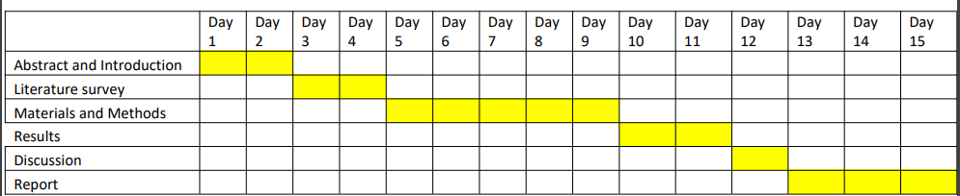

**Flow chart:-**

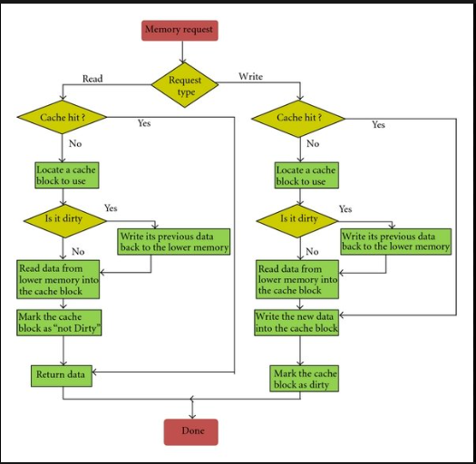

**Introduction:-**

In the realm of computer science and operating system design, memory management is a fundamental concept. Among the various techniques employed, memory paging stands out as a crucial method for efficient memory utilization. Understanding how paging operates and its impact on system performance is essential for both learners and professionals in the field.

To bridge the gap between theoretical knowledge and practical comprehension, we present "PageViz" – an innovative Memory Paging Visualization Tool. PageViz is designed to offer a dynamic and interactive platform for visualizing the intricate processes of memory paging in real-time. With its intuitive interface and powerful simulation engine, PageViz aims to demystify the complexities of memory management, making it accessible and engaging for users at all levels of expertise.

This introduction explores the key features and benefits of PageViz, highlighting its significance in enhancing educational experiences, aiding system administrators, and facilitating research in memory management strategies. Whether you're a student delving into the depths of operating systems, an educator seeking interactive teaching aids, or a professional striving to optimize system performance, PageViz promises to be a valuable asset in your journey through the realms of memory paging.

**Objectives of the Memory Paging Visualization Tool (MPVT)**

The primary goal of the MPVT is to address these challenges by providing an interactive and immersive learning environment for memory paging concepts. Specifically, the objectives of the MPVT include:

1. Enhancing Comprehension: By offering dynamic visualizations and interactive simulations, the MPVT aims to improve learners' understanding of memory paging mechanisms and their practical implications.

2. Facilitating Experimentation: The MPVT enables users to experiment with various paging algorithms, memory configurations, and process behaviour, allowing them to observe the effects of different parameters on system performance.

3. Promoting Engagement: By providing a user-friendly interface and real-time feedback, the MPVT seeks to engage learners actively in the learning process, fostering curiosity and exploration.

**Literature survey :-**

Memory paging is a fundamental concept in computer science, particularly in operating systems, and various visualization tools have been developed to aid in understanding its complexities. This literature survey aims to explore existing works related to memory paging visualization tools, highlighting their features, contributions, and areas for improvement.

1. VizMem : "VizMem: A Tool for Visualizing Memory Hierarchy and Paging Algorithms" by Chien-Wei Chang et al. (IEEE Transactions on Visualization and Computer Graphics, 2012)

Features : VizMem provides visualizations of memory hierarchy and paging algorithms, including page tables, TLB (Translation Lookaside Buffer) hits and misses, and page fault rates.

Contribution: The tool offers a comprehensive visualization of memory management mechanisms, aiding in understanding the interaction between different levels of memory hierarchy and paging algorithms.

Limitations: While VizMem provides valuable insights into memory management, its focus on memory hierarchy may overshadow detailed visualization of individual paging operations.

2. Memory Visualizer: "A Virtual Memory Management Visualization Tool" by Vishal Sikka et al. (2015 IEEE 29th International Conference on Advanced Information Networking and Applications Workshops)

Features: Memory Visualizer offers real-time visualization of virtual memory management operations, including page faults, page table updates, and memory allocations.

Contribution: The tool provides an interactive platform for students to observe the dynamic behavior of virtual memory systems, fostering a deeper understanding of memory paging concepts.

Limitations: Memory Visualizer lacks support for customization of paging algorithms and memory configurations, limiting its flexibility for exploring different scenarios.

3. VMVisual: "VMVisual: A Visual Simulation Tool for Memory Management Algorithms" by Hong-Kai Shih et al. (ACM Transactions on Computing Education, 2010)

Features: VMVisual offers visual simulations of various memory management algorithms, including paging, segmentation, and segmentation with paging.

Contribution: The tool provides a comprehensive platform for comparing different memory management techniques, aiding in understanding their advantages and limitations.

Limitations: VMVisual focuses on a broader range of memory management algorithms, potentially sacrificing depth in the visualization of individual paging operations.

4. MemSim: MemSim: A Framework for Interactive Memory Management Simulation" by Brian R. Johnson et al. (Journal of Computing Sciences in Colleges, 2010)

Features: MemSim allows users to interactively simulate memory management algorithms, including paging, segmentation, and paging with segmentation.

Contribution: The framework offers flexibility and extensibility, enabling users to customize simulation parameters and algorithms to suit their learning needs.

Limitations: MemSim lacks detailed visualizations of memory paging operations, focusing more on the simulation engine's flexibility and ease of use.

**Materials and methods:-**

In this section, we outline the materials used and the methodology employed in the development of the Memory Paging Visualization Tool (MPVT). This includes the hardware and software components utilized, as well as the steps involved in designing and implementing the tool.

**Materials:**

1.Hardware: The development of the MPVT primarily requires a standard desktop or laptop computer with sufficient processing power and memory to support software development and execution.

2. Software:

- Programming Language: The MPVT is developed using a suitable programming language such as Python, Java, or JavaScript, depending on the preferences and requirements of the development team.

- Development Environment: Integrated development environments (IDEs) like Visual Studio Code, PyCharm, or Eclipse are utilized for coding, debugging, and testing purposes.

- Graphics Libraries: Graphics libraries such as Matplotlib, D3.js, or WebGL are employed to create interactive visualizations and user interfaces.

- Simulation Engine: A simulation engine is implemented to simulate memory paging operations, including page faults, page replacements, and page table updates.

**Methodology:**

1. Requirements Gathering: The development process begins with gathering requirements through consultations with educators, students, and professionals in the field of computer science. The requirements include desired features, user interface preferences, and educational objectives.

2. Design Phase:

Architecture Design: The overall architecture of the MPVT is designed, including the components responsible for simulation, visualization, user interaction, and data management.

-User Interface Design: The user interface (UI) of the tool is designed to be intuitive, interactive, and visually appealing, ensuring ease of use for learners.

3. Implementation:

Simulation Engine: The simulation engine is implemented to emulate memory paging operations based on selected algorithms (e.g., FIFO, LRU, Clock). This involves coding algorithms for page replacement, page table management, and memory allocation.

Visualization Components: Interactive visualizations are developed to represent memory allocation, page faults, page replacements, and other relevant metrics. Graphics libraries are utilized to create dynamic and informative visualizations.

User Interface Implementation: The designed user interface is implemented using appropriate technologies such as HTML, CSS, and JavaScript (for web-based applications) or GUI frameworks (for desktop applications).

Integration: The simulation engine, visualization components, and user interface are integrated to create a cohesive and functional tool.

4. Testing and Debugging:

-Unit Testing: Individual components of the MPVT are tested in isolation to ensure their correctness and reliability.

Integration Testing: The integrated tool is tested to verify its functionality, usability, and performance under different scenarios.

User Testing: User testing sessions are conducted with target users to gather feedback, identify usability issues, and validate the effectiveness of the tool in achieving its educational objectives.

5. Deployment and Maintenance:

Deployment: The finalized version of the MPVT is deployed on appropriate platforms (e.g., web servers, app stores) to make it accessible to users.

Maintenance: Regular updates and maintenance activities are performed to address user feedback, fix bugs, and introduce new features or improvements based on evolving educational requirements.

By following this methodology, the Memory Paging Visualization Tool is developed, providing learners with an interactive and immersive platform to explore and understand memory paging mechanisms effectively.

**DISCUSSION**

The Memory Paging Visualization Tool (MPVT) offers an innovative approach to understanding memory paging mechanisms, providing interactive simulations and dynamic visualizations to aid learners in comprehending complex concepts. In this discussion, we'll delve into the implications, benefits, and potential future directions of such a tool.

1. Enhanced Learning Experience:

The MPVT significantly enhances the learning experience by offering an interactive and immersive platform for exploring memory paging concepts. Users can observe memory management operations in real-time, experiment with different scenarios, and gain insights into the inner workings of virtual memory systems. This hands-on approach fosters active learning and deepens understanding beyond what traditional teaching methods can achieve.

2. Bridging Theory and Practice:

Memory paging is often taught through theoretical explanations and static diagrams, which may abstract away the dynamic nature of memory management. The MPVT bridges the gap between theory and practice by providing a tangible representation of memory paging operations. Users can see how abstract concepts manifest in real-world scenarios, facilitating a deeper understanding of underlying principles.

3. Customization and Experimentation:

One of the key strengths of the MPVT is its flexibility and customization options. Users can adjust simulation parameters, select different paging algorithms, and modify memory configurations to explore a wide range of scenarios. This capability empowers learners to experiment with various strategies, observe their effects on system performance, and gain insights into the trade-offs involved in memory management.

4. Usability and Accessibility:

The usability and accessibility of the MPVT are crucial factors in its effectiveness as an educational tool. A user-friendly interface, intuitive controls, and clear visualizations ensure that learners can easily navigate the tool and extract meaningful insights without being overwhelmed by technical details. Additionally, making the tool accessible across different platforms and devices enables a wider audience to benefit from its educational value.

5. Future Directions:

As technology and educational needs evolve, there are several avenues for further development and improvement of the MPVT. This may include:

- Integration with Learning Management Systems (LMS) to facilitate seamless integration into educational curricula.

Incorporation of additional features such as gamification elements, collaborative learning capabilities, and adaptive learning algorithms to enhance engagement and motivation.

Expansion of the tool's capabilities to encompass other aspects of operating systems and computer architecture, providing a comprehensive learning resource for related topics.

In the realm of computer science and operating system design, memory management is a fundamental concept. Among the various techniques employed, memory paging stands out as a crucial method for efficient memory utilization. Understanding how paging operates and its impact on system performance is essential for both learners and professionals in the field.

To bridge the gap between theoretical knowledge and practical comprehension, we present "PageViz" – an innovative Memory Paging Visualization Tool. PageViz is designed to offer a dynamic and interactive platform for visualizing the intricate processes of memory paging in real-time. With its intuitive interface and powerful simulation engine, PageViz aims to demystify the complexities of memory management, making it accessible and engaging for users at all levels of expertise.

**Conclusion**

Memory paging visualization tools play a vital role in enhancing understanding and learning experiences in computer science education. While existing tools offer valuable insights into memory management mechanisms, there remains room for improvement in terms of providing detailed visualizations, customization options, and user engagement. Future research in this area could focus on developing tools that strike a balance between educational value, interactivity, and usability, catering to diverse learning needs and preferences